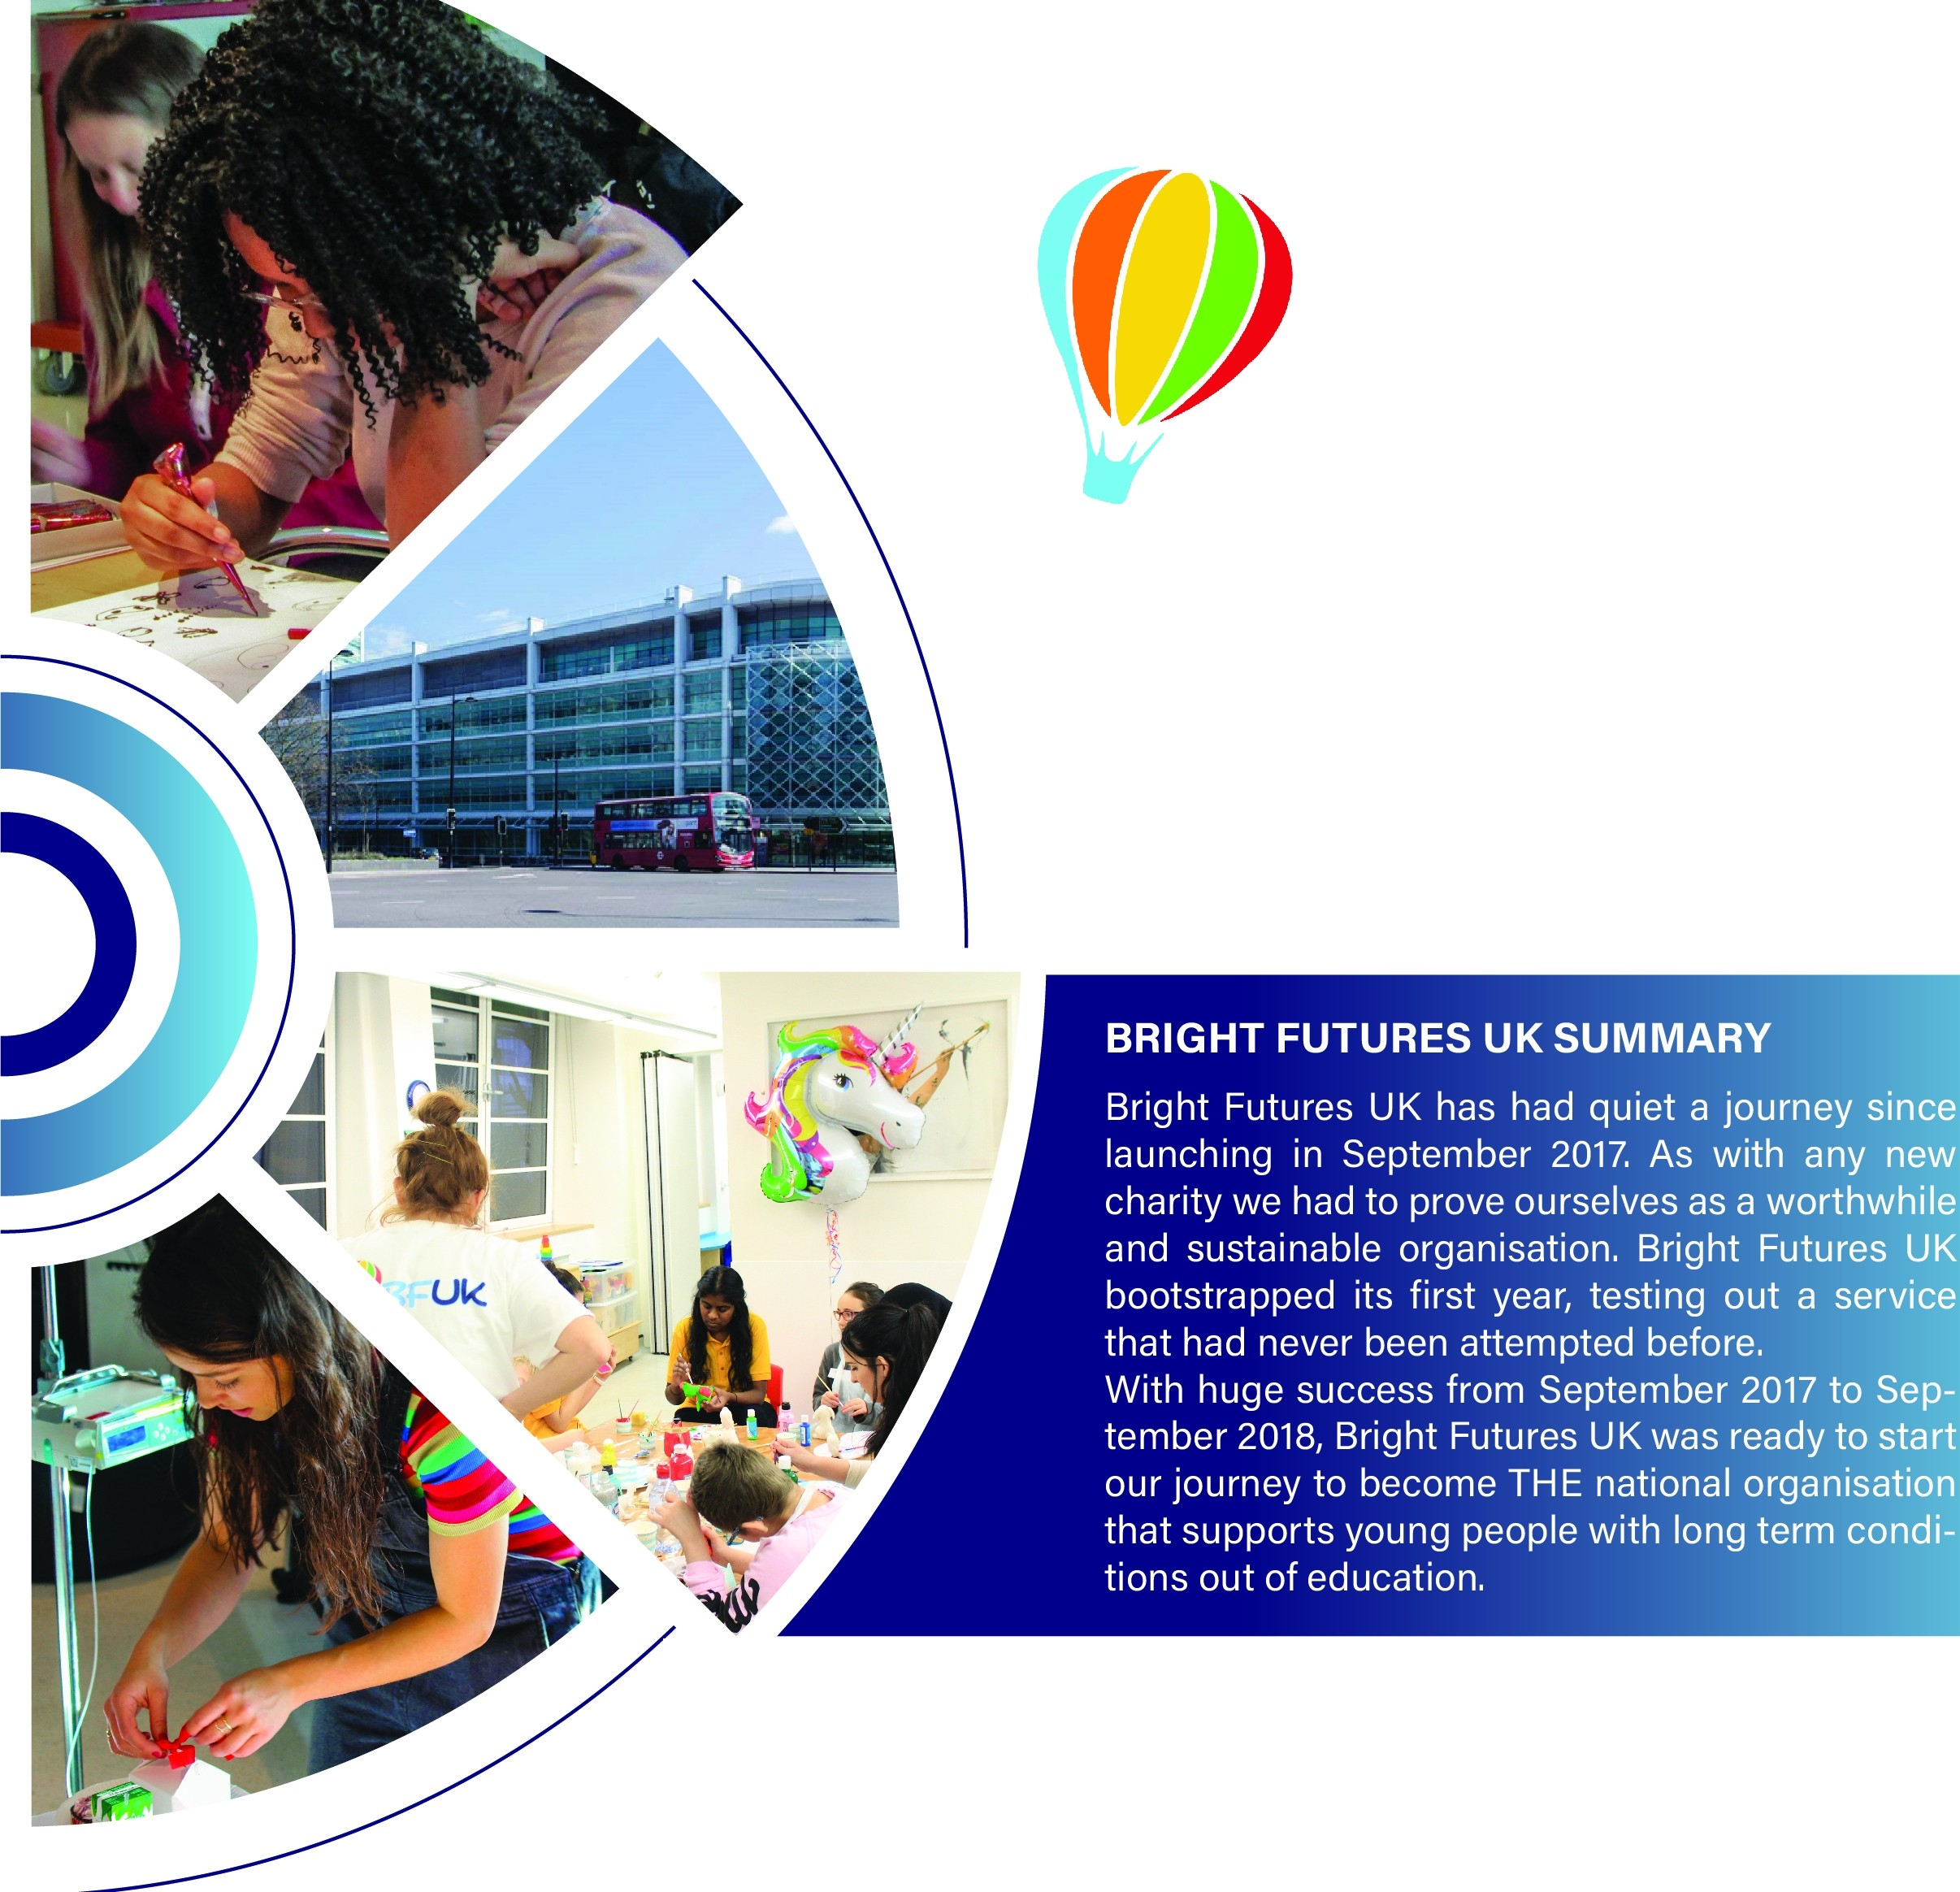13righ1" F'u-tures UL<

We grew from
A £9K annual budget in 2018 to
a £100k annual budget in 2019.

In 2018 Bright Futures UK was able to support over 350 young people. In 2019 Bright Futures UK looks to double this to over 800 young people.

We currently work alongside; Great Ormond Street
University College London Hospital The Royal Free Trust
The Royal Marsden St Thomas
And many others

